**STA 504 Homework #2**

**Due: Monday, September 18**

**Show your work to earn full credit. You are encouraged to work with your peers on assignments. The write-up must be your own.**

**Caution:** The problem labels in the following may not be different from those used in the textbook.

**Problems are chosen from Section 3.1:** Definitions of random variables and their probability distributions.

You need to use some of the concepts we covered in Chapter 2 to solve some of these problems.

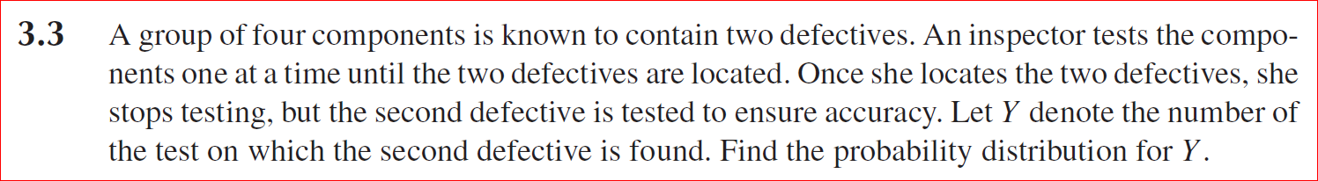

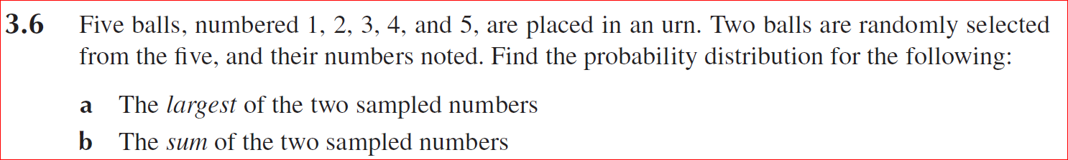

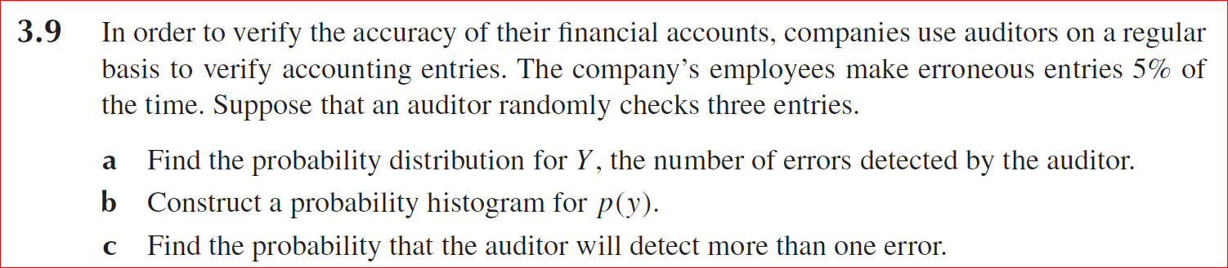

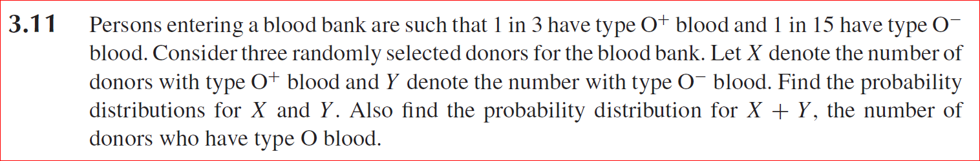

**Calculus Review**

Answer the following questions for the given function below.

$$f\left(x\right)=\frac{e^{ax+b}}{1+e^{ax+b}}$$

(1). Specify the domain and range of this function.

(2). Is this an odd function or even function? Justify your answer.

(3). Find the derivative of the function;

(4). Is this function monotonic? Justify your answer using the definition of the monotonic function.

(5). If your answer in (2) is Yes, find the inverse function of f(x), denoted by f-1(x). Please also specify the domain and the range of f-1(x). Compare the domain and range of f(x) with that of f-1(x).